Exercise: Invasion and metastasis
1) Memorization and deduction:
a) Name 3 general roles of integrins in cancer:

b) What increases the versatility of integrins to mediate such diverse functions in various cell and tissue environments?

c) Tumor invasiveness critically depends on extracellular proteolysis that is exquisitely regulated in space and time. What "barriers" exist in normal tissues to prevent that this dangerous process happens spontaneously?

2) Former exam MCQ:
Which one of the following statements about metastatic cancer cells is false:
A. They form metastases independently of known metastasis-specific driver mutations
B. They tend to upregulate stem cell-like gene signatures compared to non-metastatic cells in the same tumor
C. Binding to blood platelets facilitates their survival
D. A complete EMT is essential for the formation of macrometastases
E. They may be recognized in sentinel lymph nodes by the immune system
The process of EMT:
A. increases cell adhesion to the extracellular matrix
B. induces the degradation of basement membrane
C. correlates with increased invasion and metastasis
D. is essential for cancer cells to resist chemotherapy
E. is required for colonization

3) Tumor cell heterogeneity
a) The ability to metastasize is only acquired by a subset of cells within a given tumor. What observations and experiments support the existence of such a "hierarchy" among the cancer cells within a given tumor?
b) What explanation(s) have been offered to explain why "colonization" is not more efficient? In other words, why do micrometastatic cells only rarely give rise to macrometastases?
4) Data interpretation: Role of Id1 in metastatic lung colonization.
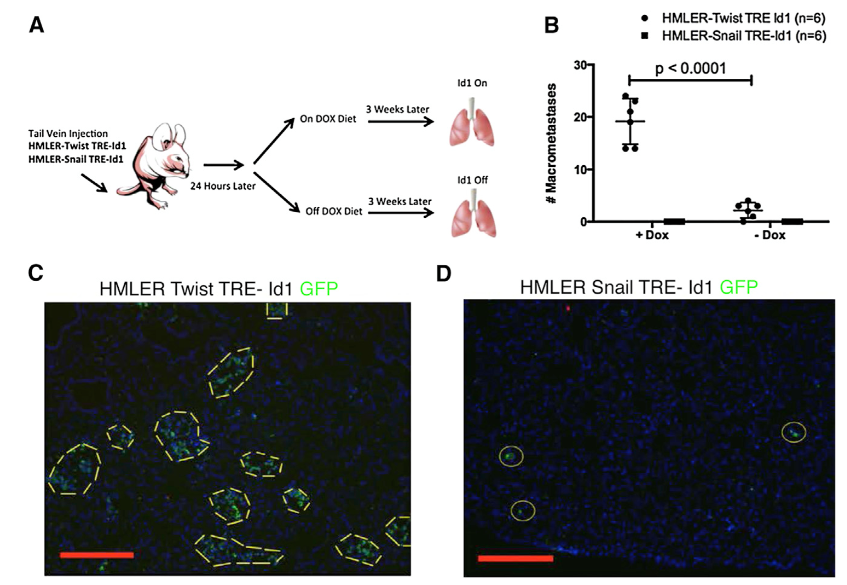
The final step of the metastatic cascade is called colonization. To test how this rate-limiting step is regulated, researchers introduced a doxycycline-regulated TRE-Id1 transgene into Ras-transformed human mammary epithelial cells (HMLER) that were engineered to stably express SV40T and a GFP marker, together with either Twist or Snail. 24 hours after injection of such engineered HMLER cells into the tail vein of immunodeficient mice, the hosts were treated with or without doxycycline (Fig. 1A), followed by analysis of GFP+ foci 3 weeks later as a readout of metastatic growth (Fig. 1B-D).
Figure 1. Influence of inducible Id1 on lung colonization by breast cancer cells that were forced to undergo EMT in vitro. (A) Experimental strategy. (B) Quantification of the number of macrometastatic outgrowths under the indicated experimental conditions. (C, D) Representative images of GFP+ clusters of metastatic cells expressing the EMT transcription factors Twist (C) or Snail, respectively (D). Source: Stankic et al., Cell Rep. 5: ﻿1228-1242 (2013)
i) What was the rationale for transducing the HMLER cells with Twist or Snail, and what effect of Id1 on the resulting cells can you observe here in vivo?

ii) What system was used here to activate the tetracycline-regulatory element (TRE) that drives the expression of transgenic Id1: The tet transactivator protein (Tet-OFF), or rather the reverse tet transactivator rtTA (Tet-ON)?
iii) Twist and Snail are key regulators of EMT during development. They have also been shown to promote metastasis in breast cancer models. Here, the authors wanted to coexpress them with or without inducible Id1. To do so, why did the authors administer doxycycline only 24 hours after the grafting of tumor cells? Why not at time zero?

iv) What did they learn about the mechanism of colonization from the fact that the resulting GFP+ metastases in panel C were much bigger than those in panel D?
v) Which metastases would you predict to stain positive for E-cadherin: Those in panel C or rather those in D, or both? Explain your answer.
vi) In the lecture on replicative immortality, we heard that Id1 can inhibit the induction of p16INK4A. Why did the authors here not consider a potential effect of Id1 expression on cellular senescence? Hint: What is SV40T?
vii) How can you exclude the possibility that Id1 here increased metastatic colonization only indirectly by facilitating tumor cells invasiveness? Hint: How important is invasion in their animal model of experimental metastasis?

